**STUDY BUDDY-Making Learning Easy**

Vrinda Kohli1, Satwik1, Swapnil Gupta1 and Mala Saraswat1

ABES Engineering College, Ghaziabad, Uttar Pradesh

**ABSTRACT :** Study buddy is an all-in-one package for your studies. We provide an automatically generated timetable as well as pdfs and video links all for Free for our students of class 10th, 12th and, those appearing for JEE. The aimis to increase job opportunities for college students with expertise in a particular subject as well as retired teachers to help school students divide their time and stay motivated. Kids nowadays are always stressed during exam days because they can’t make a schedule to study. So we wanted to bring an end to those days of anxiety and fear. We decided to make a website, “Study Buddy” where a student will have the following 4 options: a) Generate Time table b) Reference Material c) Discussion Forum d) Mentor Help.

In our research, we would walk through the above-mentioned points and also compare how our proposed method and software package stands out from the already existing software. This will be followed by our system design, result and future scope. This software is a buddy for the students during their hard times. It will not only help the students but will also provide an employment opportunity to retired teachers and college students.

**KEYWORDS:** E-learning, Online education, online platform, student guide, COVID-19, school students, requirements specification.

Introduction

COVID 19 brought with it the lockdown which further brought a mental turmoil in people. People were left sitting idle at home which took a toll on their mental health. in these pandemic situations, Online learning came as boon. virtual classrooms have become the new normal now [1]. We have been in a helpless place ourselves when we have to study weeks before our exams. Anxiety coupled with exam fear lowers our productivity.

The major motivation for our research work is:

* Increasing competition in the world has increased the need for exams.
* Valuable time gets wasted while making a timetable

This paper and software package has been developed to improve and override the problems of the existing system. In all, this research work is designed to provide easy access of learning resources to students from time to time. The objective of this research work is to help students appearing for different exams by providing them with proper resources and mentors under one platform so that they just have to focus on their preparation and nothing else. The creative and engaging user interface will be easier to understand and use by the students.

It will help retired teachers by providing them an extra source of income by helping students with their queries and problem. Schools and Colleges can also use our curriculum to teach students which we are thinking of as our future perspective. The first one who could be benefitted from our research is the students. Once the major problem is identified, the students can take up the necessary actions accordingly. The online programs could be engaged from households so there are very less chances of students missing out on lessons. Study Buddy will help all students prepare for any exams whether normal or competitive in any field. The other broader and future perspective of this research work will help teachers by providing them with a proper source of income. Study Buddy can also be accessed by schools and colleges as a source of their curriculum.

Related Previous Work

A lot of this work has already been done in this field. Websites like Udemy and Coursera are there which provide you with courses and certification but that is without effective time management learning.

Udemy provides lifelong learning with a variety of educated experts to cater to their large number of students. It is a new approach to classroom learning but with technology integrated. Their marketplace model captures the student’s and the teacher’s intention of enrolling. It is a self-sustaining model of education that provides courses to students depending on their interest and also helps to provide a source of income for the instructors [4].

Websites like two waits, brainly provide with just study material and questions answers. Because of internet erudition, technology has become a part of daily lives. Whether it is using Google Meet or teams for online classes. But they come with distractions of other video streaming platforms. These platforms Lack learner engagement and motivation.

MOOCS or the “Massive Open Online Courses” are also at a remarkable rise. Coursera and the edX are the two MOOC’s provider. They have a strong business model as they provide both free and paid courses for the students. Students can pay for the course they want to enroll in and also get a certificate of completion upon successfully completing the course.[7]

It is also debated whether MOOC’S are beneficial and if it is worth paying for the certificate? Since it contains some famous online degree programs of various universities, some students left their internships to do MOOC’s courses [9]. For automatic time table generation there have been many algorithms that are being used to reduce the time and manual work by the student. Evolutionary Algorithm and manually generated time tables are of a kind. The former is used with Heuristic and context-based reasoning method and the latter provides more of a manual work which changes depending on student’s choices. Heuristic approach is a general approach for generating the time table [3].

The idea that we are implementing is unique. We haven’t found any website that would provide a timetable for the student depending on the priority of his subjects and the deadline of the exam. It provides students with the guidance/support they need. The software we build covers all of the requirements needed by students during exam days.

**Table 1:** Analysis of different e-learning Platforms

|  |  |  |  |  |  |  |  |
| --- | --- | --- | --- | --- | --- | --- | --- |
|  | PDF | VIDEO LECTURE | LIVE CLASSES | DISCUSSION FORUM | TIMETABLE GENERATION | PROVIDING EMPLOYMENT | CERTIFICATE PROVIDED |
| UDEMY | **☒** | **☑** | **☒** | **☑** | **☒** | **☑** | **☑** |
| COURSERA | **☒** | **☑** | **☒** | **☑** | **☒** | **☒** | **☑** |
| TWOWAITS | **☑** | **☒** | **☒** | **☑** | **☒** | **☒** | **☒** |
| SITES HAVING TIME TABLE GENERATION | **☒** | **☒** | **☒** | **☒** | **☑** | **☒** | **☒** |
| **STUDY BUDDY** | **☑** | **☑** | **☑** | **☑** | **☑** | **☑** | **☒** |

The above table shows the analysis and comparison of 3 already existing e-learning websites with our software research work idea. All the websites separately cover the points, but our website brings all these points under a single roof.

While Udemy and Coursera provide with video lectures for different subjects and courses respectively, Two Waits provides with only the PDF’s. Study Buddy on the other hand contains both PDF and video lectures. Discussion forum is common amongst most of the sites.

Another thing that sets us apart is “time table generation”. The only thing lacking in Study Buddy is providing certificate of completion.

Proposed Approach

An E-learning environment has become a necessity during the pandemic. Our research work follows an easy approach similar to other-online learning portals but with our uniqueness. Our approach is as follows:

1. To provide a clear and intriguing platform that gets the attention of students using React JS.

2. The user will begin with registering himself/herself on our site and will be redirected to the login page.

3. The data will be stored in the MYSQL database.

4. From the user will enter the correct credentials to log in and will be redirected to the dashboard where he can choose what action to proceed with.

5. User will be able to navigate to either of the 4 pages: generate time table page, discussion forum page, online class page and study material page.

On **generating the timetable page,** the most suitable timetable will be provided to the user depending on the data entered by him.

On the **discussion forum page**, the students can interact with each share notes or reviews about the teacher .

On the **online class page**, they can decide the teacher and the payment plan and pay for the class accordingly.

Finally, on the **material page** the student can also download pdf notes or videos.**Registration/ Sign-up:** This interface lets users create their account on to the application and avail services that our website provides.

**Login:** This is a sub-module of sign-up page. the user inputs details that are added in the database. [2]

**Logout:** This page would redirect users to the login page.**Home Interface:** This page allows users to see posts that are posted by other users.

**Generate Time-Table:** The time-table generator comes into process now. it uses various algorithms processes the data provided by the student which includes the deadline for his exam along with the priorities of his understanding a subject and then time table will be generated. [2]

**Pricing:** This page has the pricing scheme for if the student plans to have a one-on-one interaction with the teacher.**Faculty Interface:** This screen allows all users to see the available teachers along with their designations and subject expertise.

**Discussion Interface:** Chat applications are common nowadays. Students from all parts of the world are able to communicate with each other easily. [8]

This screen allows users to direct message other users as a means of communication Interface. It will allow students to discuss syllabus as well as teachers rating and will also improve the interactivity of the website.

* 1. Technology Stack

HTML5, JavaScript, CSS3 and Bootstrap: are used for the frontend portion of the application.

Spring Boot In Java is used to write the codes for the backend. Backend is the brain of the website. We create the spring boot research work using springboot.io. Java spring boot is one of the widely used application in the Information Technology (I.T.). [10]

React Js: is used to write the code for the front end as well. It made our web page more dynamic.

MySQL: is used to store and modify data. It is the base of the software.

Swagger and Postman: for hitting the API and checking the response.

To build a chat application we would require Node Js at server end and MongoDB database. [8].

Experiment and Result

* 1. Data Flow Diagram (DFD):

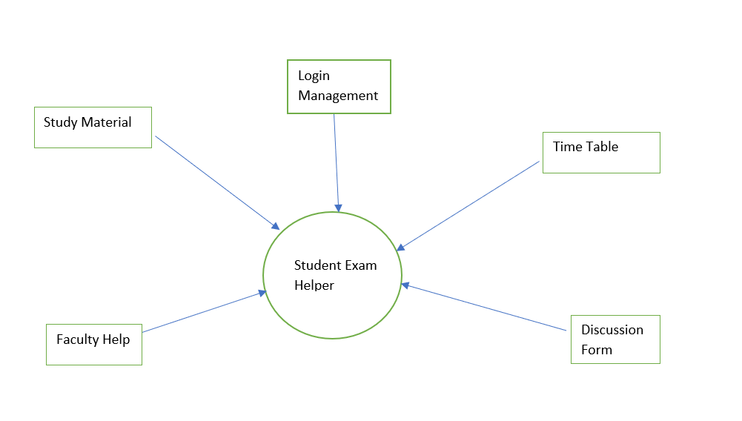

**Figure 1:** Data Flow Diagram Level 0 Of The Website

This is the basic overview of the system that we have modeled. It gives a glance view along with high-level processes.

In our DFD level-0 we have shown the 5 basic components of our website which are:

* Faculty help
* Study material
* Login
* Time table generation
* Discussion Forum

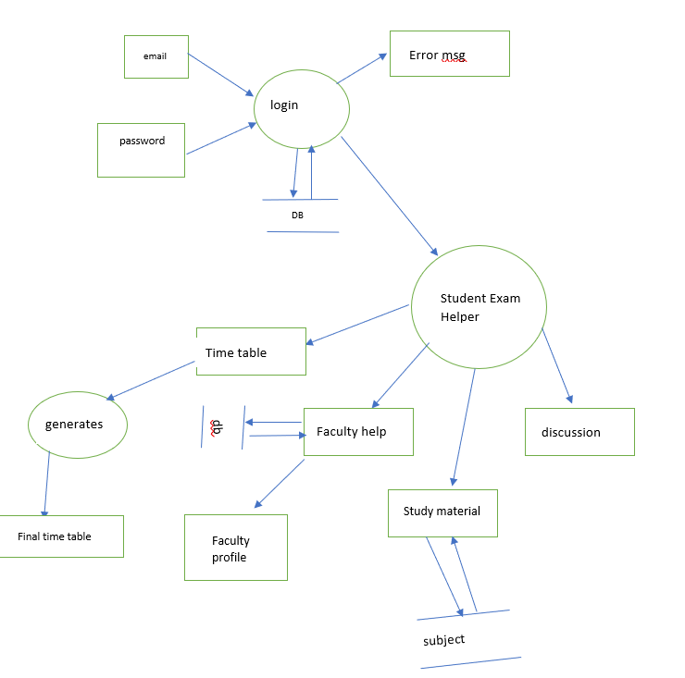

**Figure 2:** Data Flow Diagram Level 1 Of The Website

In figure 2 we have shown the DFD level 1 of our website. This includes the sub-processes of the system and gives a more exploded view of how we will execute our website.

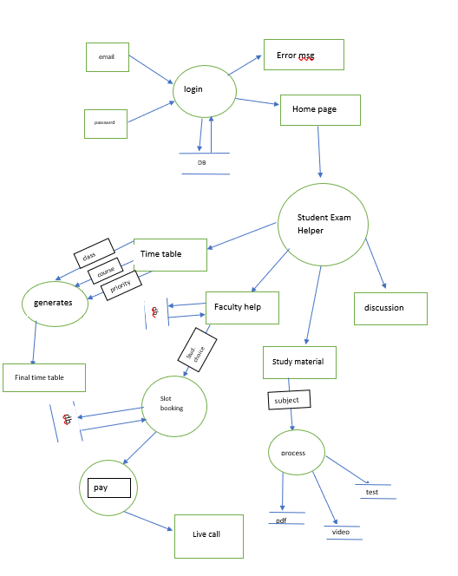

**Figure 3**: Data Flow Diagram level 2 Of The Website

In figure 3 we have represented the most elaborate form of our website which constitutes of every entity and how there are connected to the database.

We have shown the connection between each entity and the whole flow of our website from the login page to the student helper.

* 1. Use Case Diagram:

The use case diagram is an important stage in software development. It is used from developers to testers to understand the “requirement specifications”. A way to create this use case diagram is to note down all the use cases and then use tools to generate the diagram. [6]

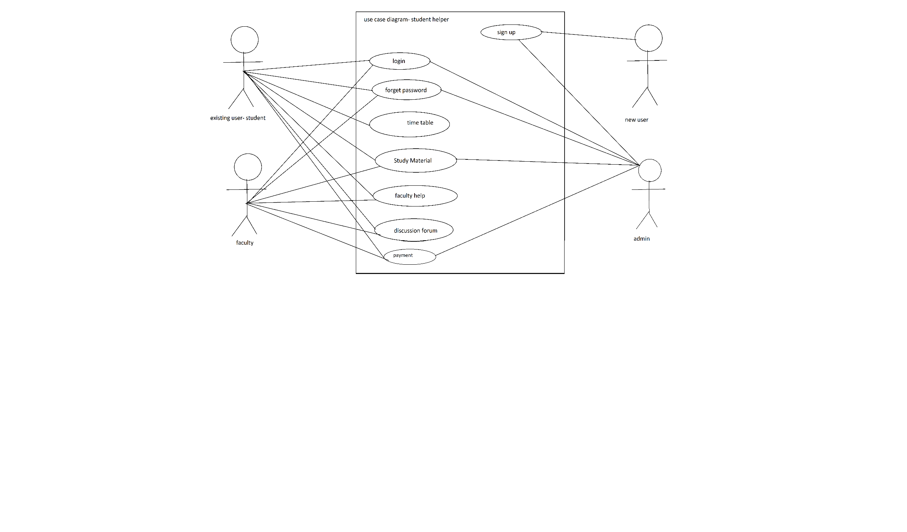

**Figure 4:** Use Case Diagram

Users can see the basic screen and faculty will have their own interface to log into. Here, a relationship between the user and the different functionalities is shown. The use case diagram shows the way the system interacts with each other and how all the components are related. It shows the users (or actors) interaction with the system.

In figure 4, there are 4 actors:

* + - 1. Existing user: this is the student who will login and access the webpage.
      2. Faculty: they have access to the live classes and their own login and registration page. They can also provide the study material.
      3. New student: the new student is allowed to register and begin his user journey.
      4. The admin: he is the master database administrator and has access to all the services.
  1. Web Outputs:

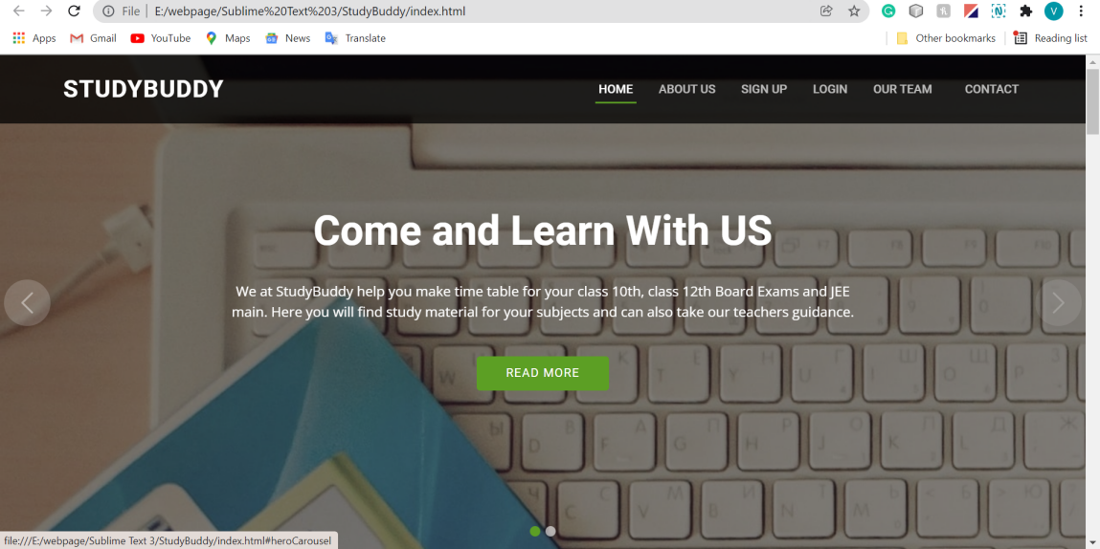

**Figure 5:** Web frontend

This is the first page of the website when the user types in the URL. It has a slider which can take it to the next image attached. This is done by using the carrousel function of bootstrap that helps us to cycle through the content. Furthermore, there are 6 options on the top. The student can navigate to any of these pages depending on his preference.

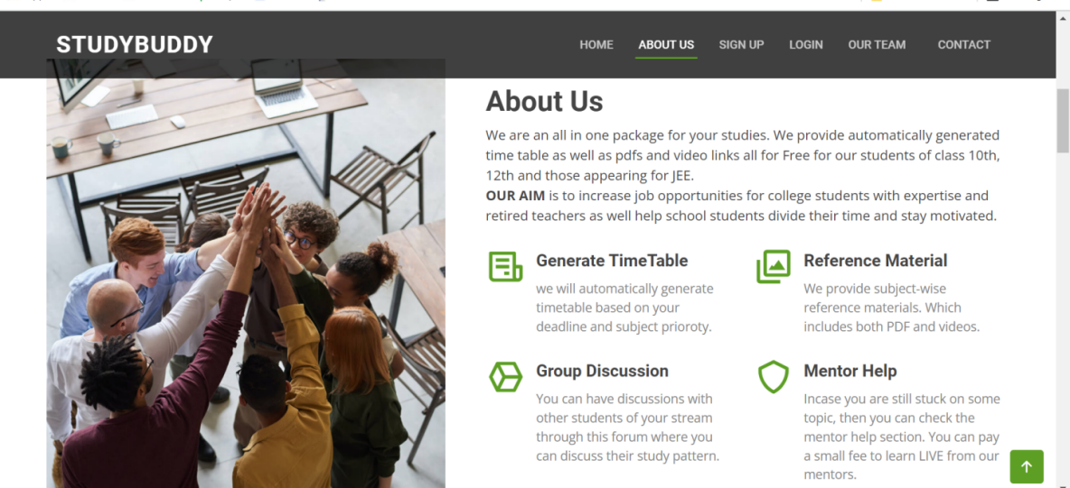

**Figure 6:** Web Frontend

Figure 6 shows the “ABOUT US” page. When the user presses on the “ABOUT US” from the navbar at the top, he will be directed to this page. The user can even scroll down to this page. It is just under the home page. Swagger is used to pass the value for input. This will later on be integrated to the sign-up page of the website and values will be passed as these arguments. Finally, after the successful execution of the POST operation, the data will be reflected in the MySQL database in the student bean, which is the student table.

Conclusion and Future Directions

From the results, we can see that when inserting the data from the REST API, our data is visible in the database. This holds for all the tables.

We have used the GET, POST, PUT and DELETE methods and all are working fine.

We are further planning to incorporate data analysis and machine learning to study the majority and the type of students using our website. We want to expand our website and timetable generation capability to not only the BOARD classes but also to all the classes as well for competitive exams like GMAT, GRE, etc. It has been found that 54.4% of the students prefer online uploaded video lectures and only 27.04% students prefer live classes. So by providing the study material to the student along with video lectures, we are helping the students make studying easier and fun. [5]**.** We may not satisfy all the criteria at the moment; however, we plan to extend our research work.We intend to make a separate mobile application that would be easily accessible for all students and teachers that can be managed by all as well. We also intend to add certain features like extending it to all classes and then even to the college curriculums. We would like to include other competitive exams like GATE, CAT, etc. preparation also. Finally, it is very important to protect our website from cyber-attacks. The CSRF attack being the most common attack where the attacker can illegally pass the authentication. So we will also include a “browser-based CSRF detection model” to prevent the attacker from attacking [11].

**REFERENCES**

[1] Jena, P.K., 2020. Online learning during lockdown period for covid-19 in India. International Journal of Multidisciplinary Educational Research (IJMER), 9.

[2] Ambhore, S., Walke, P., Ghundgrudkar, R., Alone, A. and Khedkar, A.,

Automatic Timetable Generator.

[3] Abhinaya, V., Sahithi, K. and Akaanksha, K., 2019. Online Application of Automatic

Time-Table Generator. *International Research Journal of Engineering and Technology*

*(IRJET)*, *6*(02).

[4] Qiu, R., 2020. Udemy: Blended and e-Learning for Transforming Teaching and Learning. In Anticipating and Preparing for Emerging Skills and Jobs (pp. 215-220). Springer, Singapore.

[5] Muthuprasad, T., Aiswarya, S., Aditya, K.S. and Jha, G.K., 2021. Students’ perception and preference for online education in India during COVID-19 pandemic. Social Sciences & Humanities Open, 3(1), p.100101.

[6] Hnatkowska, B. and Cebinka, M., 2021. Activity Diagram Generation Based on Use-Case Textual Specification. Computing and Informatics, 40(4), pp.772-795.

[7] Mamgain, N., Sharma, A. and Goyal, P., 2014, December. Learner's perspective on video-viewing features offered by MOOC providers: Coursera and edX. In 2014 IEEE International Conference on MOOC, Innovation and Technology in Education (MITE) (pp. 331-336). IEEE.

[8] Henriyan, D., Subiyanti, D.P., Fauzian, R., Anggraini, D., Aziz, M.V.G. and Prihatmanto, A.S., 2016, October. Design and implementation of web based real time chat interfacing server. In 2016 6th International Conference on System Engineering and Technology (ICSET) (pp. 83-87). IEEE.

[9] Despujol, I., Castañeda, L. and Turró, C., 2022. What Does the Data Say about Effective University Online Internships? The Universitat Politècnica de València Experience Using MOOC during COVID-19 Lockdown. Sustainability, 14(1), p.520.

[10] Luan, X., 2021. IMPLEMENTATION AND ANALYSIS OF SOFTWARE

DEVELOPMENT IN SPRING BOOT (Doctoral dissertation, California State

Polytechnic University, Pomona).

[11] Zhang, J., Hu, H. and Huo, S., 2021. A Browser-based Cross Site Request Forgery

Detection Model. In Journal of Physics: Conference Series (Vol. 1738, No. 1, p. 012073).

IOP Publishing.